RESOLUTION NO.__________

RE: CERTIFICATE OF APPROPRIATENESS UNDER THE
PROVISIONS OF THE ACT OF THE PENNSYLVANIA
LEGISLATURE 1961, JUNE 13, P.L. 282 (53
SECTION 8004) AND BETHLEHEM ORDINANCE NO.
3952 AS AMENDED.

WHEREAS, it is proposed to replace the roof at 323 W 4th Street.

NOW, THEREFORE, BE IT RESOLVED by the Council of the City of Bethlehem that a Certificate of Appropriateness is hereby granted for the work.

Sponsored by: (s)

(s)

ADOPTED BY COUNCIL THIS DAY OF

(s)
President of Council

ATTEST:

(s)
City Clerk

HISTORIC CONSERVATION COMMISSION

CASE # 635– It is proposed to replace the roof at 323 W 4th Street.
OWNER/APPLICANT: Mark Plosa

The Commission upon motion by Mr. Cornish seconded by Mr. Traupman adopted the proposal that City Council issue a Certificate of Appropriateness for the proposed work described herein:

- The proposal to replace the roof at 323 W 4th Street was represented by Mark Plosa.
- The existing asphalt shingles will be replaced with Tamko Heritage shingles in Oxford Gray.
- Because this roof is not highly visible from the public right of way, architectural shingles were approved.
- The motion to approve the proposed work was unanimously approved.

CU: cu
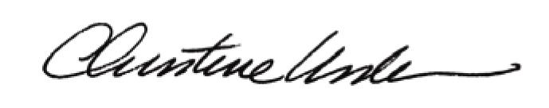

By:

Date of Meeting: November 20, 2017 Title: Historic Officer

